SBR-X
Self-Balancing Robot with Line Following and Obstacle Avoidance
Technical Report

Prepared by
Frais Asghar
September 2026
Version 1.0

Table of Contents
1. Executive Summary 3
2. Introduction 3
2.1 Background 3
2.2 Problem Statement 3
3. Objectives 3
4. System Design 3
4.1 System Architecture 3
4.2 Control Loop 4
4.3 Mode State Machine 5
5. Hardware 5
5.1 Chassis 5
5.2 Components 6
5.3 Wiring 6
6. Methodology 7
6.1 Sensor Fusion 7
6.2 PID Control 7
6.3 Mode Logic 7
7. Results 7
7.1 Observed Behavior 8
7.2 Suggested Test Log 8
8. Discussion and Limitations 8
9. Roadmap 9
10. Conclusion 9
11. References 9

1. Executive Summary
SBR-X is a two-wheeled robot that balances itself upright in real time using closed-loop PID control. Beyond balancing, it offers two selectable autonomous driving modes: line following and obstacle avoidance, both layered on top of the same balance loop so stability is never compromised while the robot is steering. This report documents the system architecture, hardware, control methodology, and results of the project, along with a roadmap for planned future work.
All sensing, control, and actuation logic runs on a single microcontroller with no external computer or cloud dependency, making the robot fully self-contained once its firmware is flashed.

2. Introduction

2.1 Background
Two-wheeled robots are inherently unstable systems. Without continuous correction they fall, since the wheelbase provides no static support in the direction of travel. Keeping such a robot upright requires fast, reliable sensing of tilt combined with a control loop that reacts before the robot falls out of recoverable range.

2.2 Problem Statement
Most hobby robotics platforms handle only one behavior at a time: either they balance in place, or they drive and steer without needing to balance. There was a need for a compact platform that could remain upright on its own while still reacting intelligently to its surroundings, whether that meant tracking a path on the ground or steering around an object in front of it, all without a separate computer or added structural support.

3. Objectives
This project set out to build a robot that balances on its own and still behaves intelligently while moving. It focused on combining stable control with real time sensing in a single compact embedded system.
- Read tilt data from an IMU and filter it for stability
- Build a PID loop to keep the robot upright
- Add line following using a reflectance sensor array
- Add obstacle detection using ultrasonic sensors
- Let a single button switch between all driving modes
- Keep the whole system running on one microcontroller

4. System Design

4.1 System Architecture
The system is organized into three stages: sensing, control, and actuation. Sensor data from the IMU, ultrasonic sensors, and IR array feeds into the control stage, which produces a single corrected lean angle that drives the motors through the motor driver. Every actuation command traces back through the same balance loop, so line following and obstacle avoidance never override stability, they only steer it.
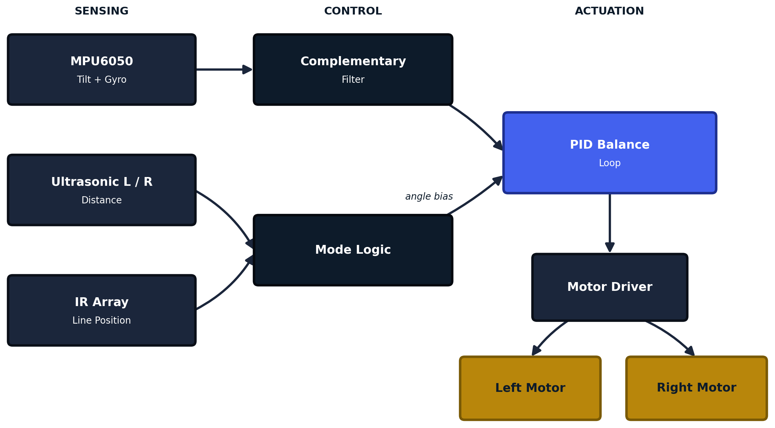
Figure 1. SBR-X system architecture: sensing, control, and actuation stages.

4.2 Control Loop
The balance loop runs continuously at a fixed rate. On each cycle it reads the current tilt angle, checks whether the robot is still within a recoverable range, and if so computes a PID correction. The active driving mode (line following or obstacle avoidance) applies a small bias to the target lean angle before the result is sent to the motor driver as a PWM signal. If the tilt angle ever exceeds the safe range, the loop cuts motor output as a fail-safe stop rather than attempting to correct from an unrecoverable position.
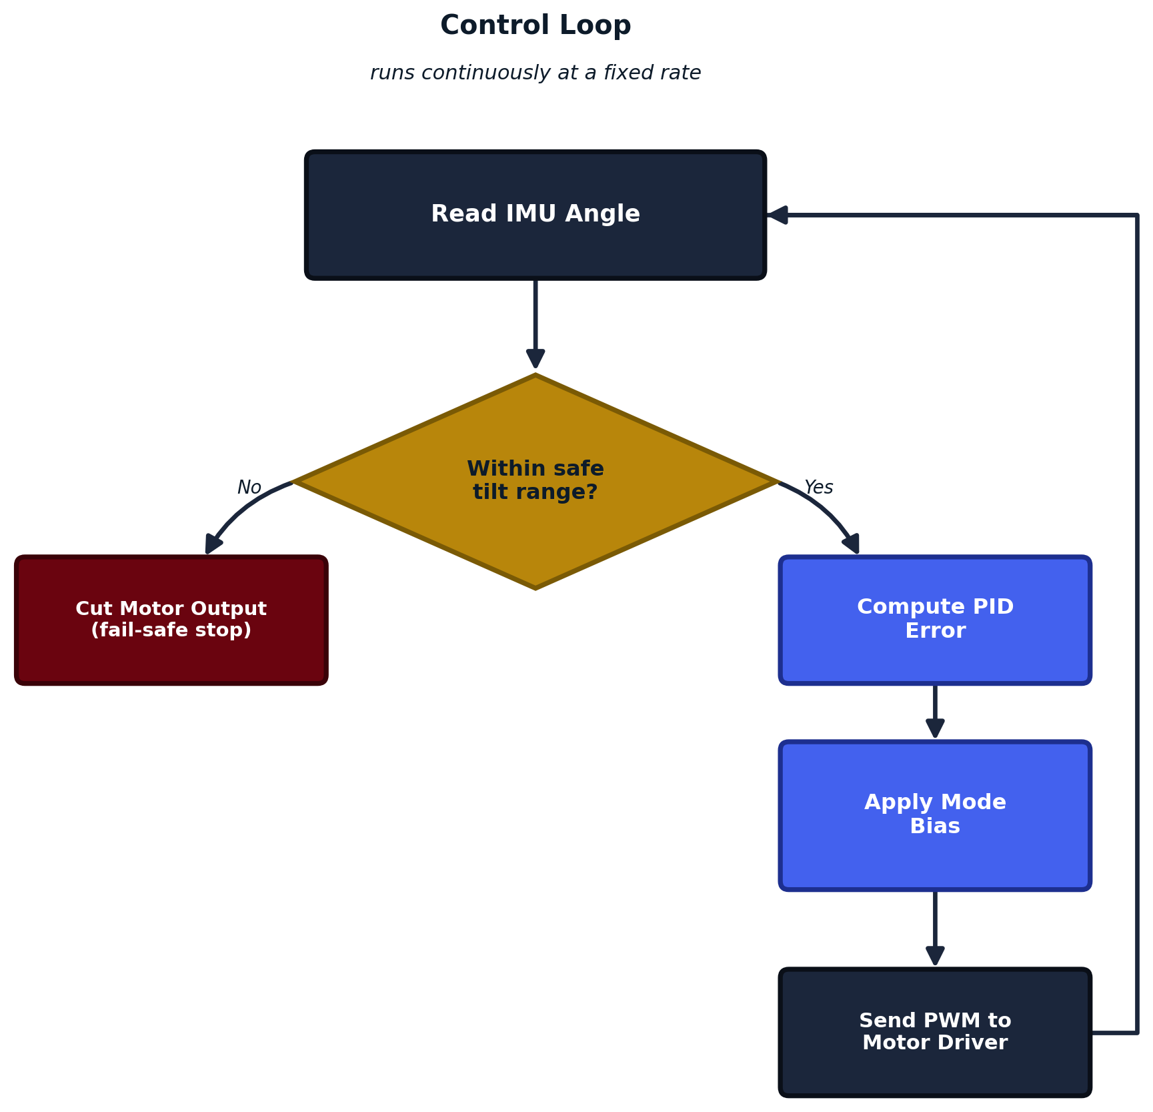
Figure 2. Balance control loop, including the fail-safe stop condition.

4.3 Mode State Machine
A single push button cycles the robot through its three operating modes. Balance is always active underneath; the button only changes which outer behavior biases the lean angle.
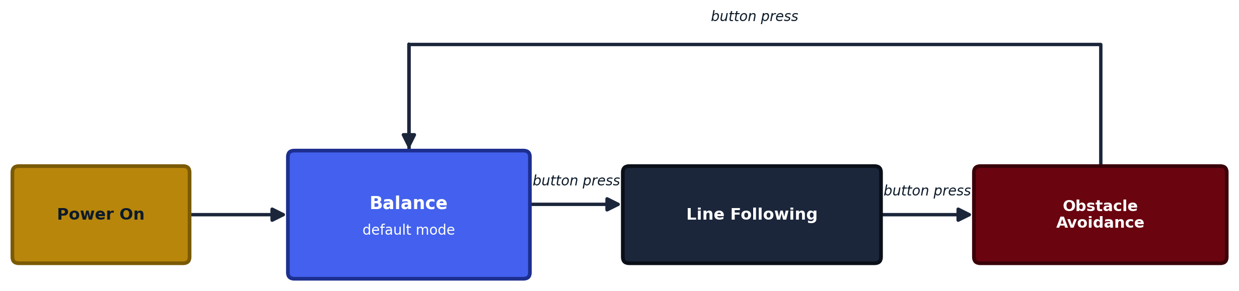
Figure 3. Mode transitions triggered by the push button.

5. Hardware

5.1 Chassis
The robot is built on a tiered acrylic chassis: the battery deck sits on top, the driver, IMU, and ultrasonic sensors occupy the middle stage, and the dual-wheel drive base forms the bottom layer.
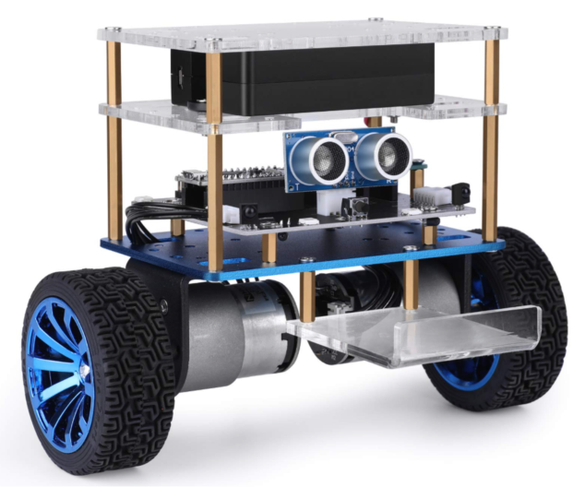
Figure 4. SBR-X chassis, showing the battery deck, sensor stage, and drive base.

5.2 Components
Table 1 lists the core components used in the build.
Part | Role | Qty
Arduino Uno / Nano | Main controller, runs the PID loop and mode logic | 1
MPU6050 (accelerometer + gyroscope) | Measures tilt angle and angular velocity for balancing | 1
Dual ultrasonic sensor module | Forward obstacle detection | 1
IR line sensor array | Line detection for line-following mode | 1
L298N / TB6612FNG motor driver | Drives both DC motors from controller PWM signals | 1
DC gear motors with wheels | Drive wheels | 2
Li-ion battery pack | Onboard power for logic and motors | 1
Acrylic chassis (tiered mounting plates) | Structural frame for all stages | 1
Mode select push button | Switches between balance, line-follow, and avoid | 1

Table 1. SBR-X bill of materials. Update quantities and part names to match your final build.

5.3 Wiring
Table 2 lists the signal-to-pin mapping assumed for this build.
Signal | Component | Controller Pin
SDA / SCL | MPU6050 | A4 / A5
Trig / Echo (L) | Ultrasonic sensor, left | D2 / D3
Trig / Echo (R) | Ultrasonic sensor, right | D4 / D5
IR array (analog) | Line sensor | A0 to A3
IN1 to IN4 | Motor driver | D6 to D9
ENA / ENB | Motor driver (PWM speed) | D10 / D11
Mode button | Push button | D12

Table 2. Pin assignments. These are placeholders, replace with the actual wiring once finalized.

6. Methodology

6.1 Sensor Fusion
Raw accelerometer readings are noisy but drift-free, while raw gyroscope readings are smooth but drift over time. A complementary filter blends the two: the gyroscope's integrated angle dominates over short timescales, while the accelerometer's angle estimate slowly corrects any accumulated drift. This gives a stable, low-latency tilt estimate suitable for a tight control loop.

6.2 PID Control
The filtered tilt angle is compared against a target angle of zero degrees, or a small offset when a driving mode is active. The resulting error passes through a PID controller: the proportional term reacts to the current tilt, the integral term corrects any steady lean caused by an uneven center of mass, and the derivative term damps oscillation so the robot settles rather than overshoots. The output is written to the motor driver as a PWM duty cycle, split between the two motors.

6.3 Mode Logic
In line-following mode, the IR array reports how far the sensed line is from center; this offset is converted into a small differential bias between the two motors. In obstacle-avoidance mode, the two ultrasonic sensors report distance on the left and right; when an obstacle is detected within a threshold range, the mode logic biases the robot to steer away from it. Both cases only ever bias the PID target, never bypass it, so the robot cannot lose its balance while executing either behavior.

7. Results
The chart below illustrates the expected shape of the balance loop's step response: a disturbance is applied, and a well-tuned PID controller brings the tilt angle back within a tolerance band and holds it there. This plot is conceptual and intended to explain the control behavior, it should be replaced with logged sensor data once test runs are recorded.
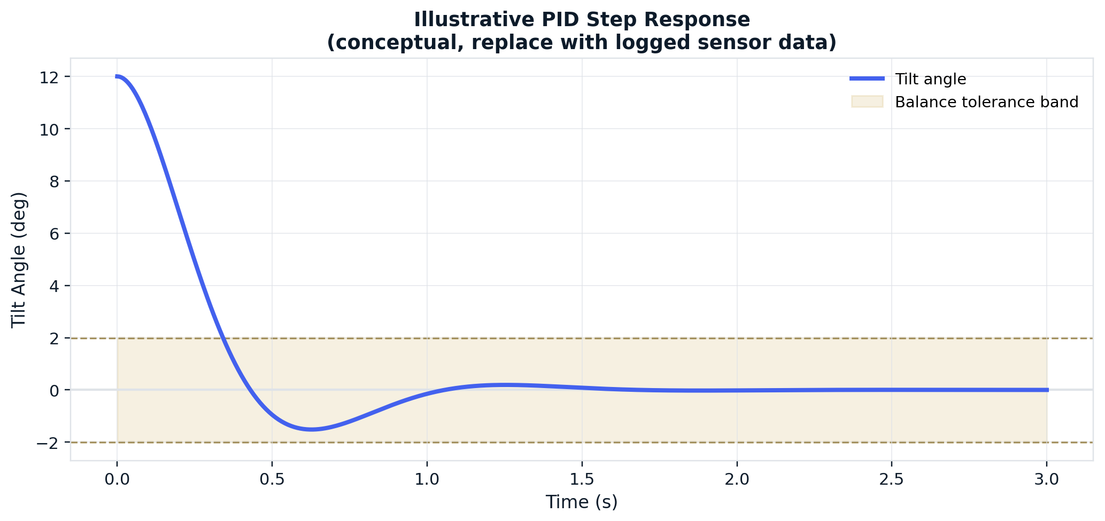
Figure 5. Illustrative PID step response. Replace with logged tilt-angle data from the physical robot.

7.1 Observed Behavior
- Maintains stable balance during idle, line following, and obstacle avoidance
- Follows a line accurately using the IR reflectance array
- Detects and steers around obstacles using the ultrasonic sensors
- Switches modes reliably with a single button press
- Runs entirely standalone on the microcontroller with no external computer

7.2 Suggested Test Log
Table 3 provides a template for recording quantitative results once bench and field testing are complete.
Test | Metric | Target | Measured
Balance hold | Max tilt deviation (deg) | < 3
Balance hold | Recovery time from 15 deg push (s) | < 1.5
Line following | Track completion rate (%) | N/A
Obstacle avoidance | Detection range (cm) | N/A
Obstacle avoidance | Successful avoidance rate (%) | N/A
Mode switching | Response time to button press (ms) | N/A

Table 3. Test log template. Fill in target and measured values from actual testing.

8. Discussion and Limitations
Layering line following and obstacle avoidance as a bias on top of the balance loop, rather than as independent motor commands, keeps the robot stable by construction: no driving behavior can request an output that the PID loop has not already validated against the current tilt angle.
The current design assumes a flat, hard surface; soft or uneven flooring changes the effective motor response and may require re-tuning the PID constants. Battery voltage sag over a discharge cycle can also shift motor response and may warrant a voltage-compensated PWM output in a future revision.

9. Roadmap
Planned development is organized into five phases, moving from core stability to full autonomy.
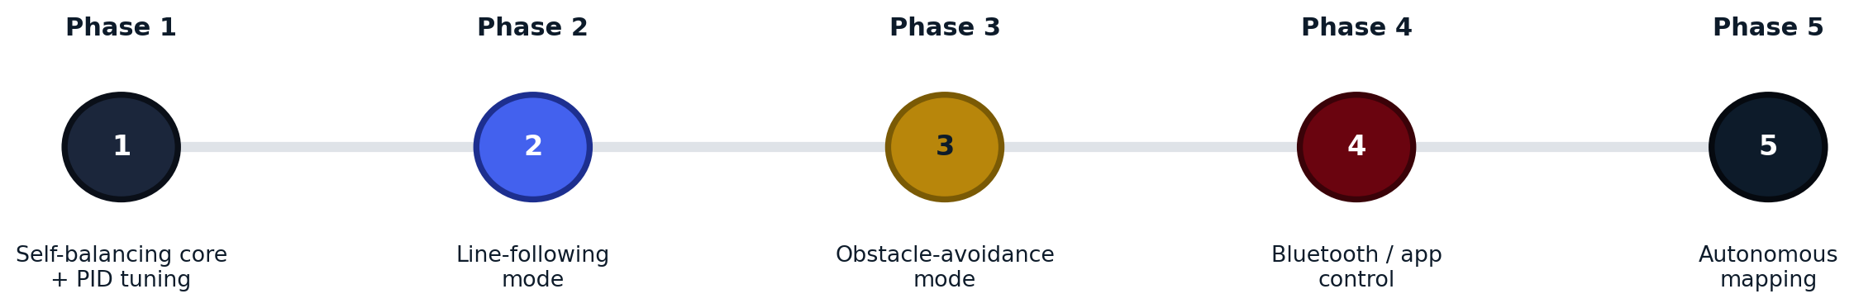
Figure 6. SBR-X development roadmap.
Phase | Milestone
Phase 1 | Self-balancing core and PID tuning
Phase 2 | Line-following mode
Phase 3 | Obstacle-avoidance mode
Phase 4 | Bluetooth / app control
Phase 5 | Autonomous mapping

10. Conclusion
SBR-X demonstrates that a single microcontroller can balance a two-wheeled robot in real time while also running autonomous driving behaviors on top of that balance loop. The layered architecture, sensing feeding a PID core that mode logic can only bias, keeps the system stable while still leaving room to add new driving modes in future phases without touching the core control loop.

11. References
Ang, K. H., Chong, G., and Li, Y. PID Control System Analysis, Design, and Technology. IEEE Transactions on Control Systems Technology.
InvenSense. MPU-6000 and MPU-6050 Product Specification.

